Test Plan for ParaBank Web Application
Project Name: ParaBank Demo Banking Website
Test Plan ID: TP-PB-001
Prepared By:
Date: October 2025
Tested URL: https://parabank.parasoft.com/parabank/index.htm

1. Introduction
The purpose of this Test Plan is to define the testing strategy, scope, objectives, and resources required to test the ParaBank web application.ParaBank is a demo online banking system that allows users to perform various operations such as registration, login, viewing account details, transferring funds, paying bills, and requesting loans.This document ensures that all functionalities of the system are tested properly to verify that the application works as expected and meets user requirements.
2. Objectives
- Check Core Features: Make sure everything related to buying works perfectly, like adding products to the cart, filtering items, and finishing the checkout process
- Test the Full User Journey: Verify that a user can go from the home page to the "Order Success" page without any broken links or system errors
- Find and Fix Bugs: Discover any functional or UI issues (like overlapping text or buttons that don't click) and report them to be fixed
- Verify Login & Security: Ensure the login system works correctly and that user data and orders are handled safely
- Check Different Screens: Make sure the website looks good and works well on different browsers (Chrome, Firefox, etc.) and different screen sizes
- Ensure Data Accuracy: Double-check that prices, quantities, and totals in the cart are always calculated correctly
.

3. Scope
In Scope:
3. Scope
In Scope
User registration
• Input validation for authentication fields (username & password)
• Forgot password functionality
• User authentication (login, logout, and session management)
• User profile update functionality
• Product search functionality including name and keyword search with results display
• Product browsing and category navigation
• Shopping cart functionality (add/update/remove items, subtotal calculation)
• Checkout and order submission workflow including cart review and order confirmation
• Order processing and history functionality
• Invoice generation functionality

Out of Scope:

•Backend internal testing (handled by development team)
• Database-level testing and validation (if not applicable)
• Security penetration and advanced security testing
• Performance, load, and stress testing
• Integration with external third-party payment gateways (demo environment
limitation)
• Production deployment and environment-specific testing

4. Test Items / Features to be Tested
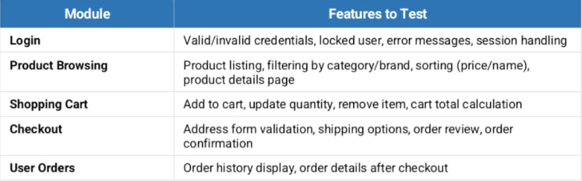

5. Test Approach
• testing Types:
• Functional Testing – Verify core e-commerce workflows (login, cart, checkout).
• UI/UX Testing – Ensure layout, buttons, and navigation render correctly.
• Boundary Value Analysis – Test field limits (e.g., quantity, form inputs).
• Input Validation Testing – Verify error messages for invalid or empty inputs.
• Compatibility Testing – Chrome, Firefox, Edge (latest versions).
• Regression Testing – Re-test critical flows after any change.
• Exploratory Testing – Ad-hoc scenarios to discover unexpected defects.
- Techniques:
• Black-box testing (tester has no access to source code).
• Positive and negative test scenarios for each feature.
• Equivalence partitioning for form field validations.
• End-to-end testing covering the full purchase flow.
- Tools:
• Manual Testing – Microsoft Excel / Google Sheets for test case management.
• Automation – Selenium WebDriver (Java/Python) for regression suites.
• Bug Tracking – JIRA or Excel defect log.

6. Test Environment
Item | Description
Environment | Web-based demo (hosted on Parasoft servers)
URL | https://parabank.parasoft.com/parabank/index.htm
Browser | Chrome (latest), Firefox, Edge
OS | Windows 11
Tools | Postman ,burp suite (API), JIRA or Excel (bug tracking), Selenium (automation)

7. Test Data
Example Test Data for Registration:
Field | Valid Input | Invalid Input
First Name | Shahd | "" (blank)
Address | 123 Test Street | @@@@
City | Cairo | 123
State | Egypt | (blank)
Zip Code | 12345 | abcd
SSN | 123-45-6789 | abc-123
Username | shahdTest | (already used username)
Password | Test@123 | test

8. Entry and Exit Criteria
Entry Criteria:
- Functional requirements are clearly defined.
- Website is deployed and accessible.
- Test environment is ready.
Exit Criteria:
- All test cases executed.
- All critical and major defects resolved.
- Test summary report prepared.

9. Deliverables
- Test Plan Document
- Test Cases Document
- Test Execution Report
- Defect Log
- Test Summary Report

10. Risks and Mitigation
Risk | Mitigation
Website downtime (demo server) | Retry after some time / backup environment
Frequent data reset | Recreate test data before each test cycle
Inconsistent response time | Record results across multiple attempts

11. Test Schedule (Not Final)
Activity | Start Date | End Date
Test Plan Preparation | 18 Oct 2025 | 22 Oct 2025
Test Case Design | 22 Oct 2025 | 26 Oct 2025
Test Execution | 26 Oct 2025 | 10 Oct 2025
Test Closure | 10 Nov 2025 | 15 Nov 2025

Team Members

Mohraieel Nasser karam Team Leader/QC
Verina Amgad Ayad QC Engineer
Ahmed Mohamed Ali QC Engineer
Sara Ahmed Elshrief QC Engineer
Germeen George Halim QC Engineer
Abdulrahman Mohamed Owies QC Engineer

